 | 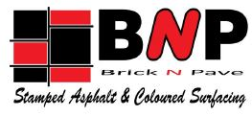 |  |  | SAFE WORK METHOD STATEMENT
 |  |  |  | BNP SWMS 08 - StreetBond V2 |  |  |  |  |  |  |  |  |  |  |  |  | Issued 15-May-25
 | ABN: 69 056 378 575 |  |  |  | ACN: 056 378 575 |  | 11 Huntington Place, Banyo QLD 4014 |  |  |  |  |  |  |  |  |  |  | PH: (07) 3630 2500
Project |  |  |  |  |  |  |  |  |  |  |  |  |  | Project No
Client |  |  |  |  |  |  |  |  |  |  | Location
Person in control of works |  |  |  |  |  |  |  |  |  |  | Contact Number
Work Activity |  | Applying StreetBond
High Risk Construction Activities |  | Risk of a person falling more than 2 metres |  |  |  |  |  |  |  | Work in or near a confined space |  |  |  |  |  | Work in or near a shaft or trench deeper than 1.5 m or a tunnel
 |  | Work on or near pressurised gas mains or piping |  |  |  |  |  |  |  | Work on or near energised electrical installations or services |  |  |  |  |  | Work on, in or adjacent to a road, railway, shipping lane or other traffic corridor in use by traffic other than pedestrians
 |  | Work in an area with movement of powered mobile plant |  |  |  |  |  |  |  | Work in or near water or other liquid that involves a risk of drowning |  |  |  |  |  | Is carried out in an area that may have a contaminated or flammable atmosphere
Consultation in development of SWMS |  | Name |  |  |  |  |  | Position |  |  |  |  | Signature |  |  |  |  |  |  |  | Date
 |  | Greg Steele |  |  |  |  |  | Director |  |  |  |  | 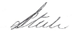
 |  | Brendan Evans |  |  |  |  |  | QLD Manager |  |  |  |  | 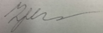
Approved by |  | Brendan Evans |  |  |  | Position |  |  | QLD Manager |  |  | Signature |  |  |  |  |  |  | Date
 | Legislation and Codes of Practice |  | Work Health & Safety Act 2011, Work Health & Safety Regulation 2011, How to Manage Work Health and Safety Risks COP 2011, Work Health and Safety Consultation, Co-operation and Co-ordination 2011  Traffic Management for Construction or Maintenance Work Code of Practice 2008, MUTCD Part 3  Managing the Risks of Hazardous Chemicals Code of Practice 2021, Hazardous Manual Tasks Code of Practice 2021, Managing Risks of Plant Code of Practice 2021, Abrasive Blasting Code of Practice 2021, First Aid in the Workplace Code of Practice 2021
 | Plant and Equipment required |  | Mixer, air compressor, paint gun.
 | Inspections and maintenance |  | Preoperational check to be conducted on plant
 | Materials used |  | StreetBond Coating
 | Specific Training |  | General industry induction (QLD white card); Site specific induction, trained in SWMS / SDS procedures, Trained in Safe & Proper Use of PPE
 | Personal Protective Equipment |  | Mandatory PPE to be worn at all times – Hi-Vis Long Sleeve shirt – (Sleeves rolled down) or Hi-Vis vest over shirt, Long pants, Safety glasses, gloves when Manual Handling, Safety helmet where required.  Task PPE – Ears plugs (over 70db), Respirators, Knee high leather chaps

Implement, Monitor and Review
Actions before work commences | Workers will be inducted onto the Safe Work Method Statement  Traffic management controls, approved plans and permits must be in place before working within 6mtrs of live traffic.  All traffic controllers must hold the relevant qualification for the role. Evidence must be sighted prior to start of works.  Works must be planned and structured to cause minimum disruption to local traffic, pedestrians and residents.  Conduct pre-operational checks on plant
Actions during works | Signage checks must be completed at regular intervals and documented throughout the day.  Works will be monitored to ensure works are carried out in accordance with the Safe Work Method Statement  Report any hazards or incidents.  Person in control of the works is the nominated person who will ensure the implementation of this SWMS.  All incidents and / or near misses must be reported following the Brick N Pave incident reporting process.
Actions after work is completed | Safe Work Method Statement will be reviewed and amended when changes are made or where a new hazard has been identified, or at least annually

Risk Assessment

HEALTH & SAFETY CONSEQUENCES |  | 1. INSIGNIFICANT  - no injuries | 2. MINOR  - first aid treatment, spillage contained on site | 3. MODERATE  - medical treatment, spillage contained with outside help | 4. MAJOR  - extensive injuries, loss of production | 5. CATASTROPHIC  - death, toxic release of chemicals | 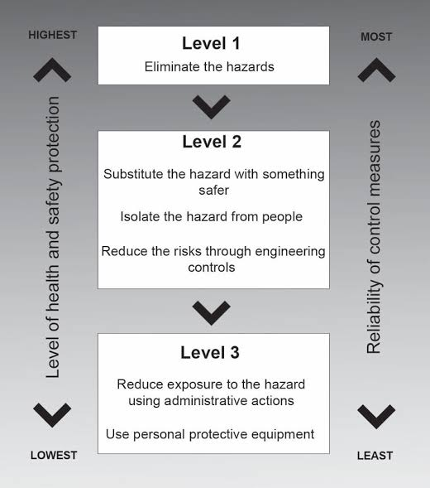
PROBABILITY | A. Common or Frequent Occurrence | M5 | M10 | H15 | E20 | E25
PROBABILITY | B. Is known to Occur or ‘It Has Happened” | L4 | M8 | H12 | E16 | E20
PROBABILITY | C. Could Occur or “I’ve Heard of it Happening” | L3 | M6 | M9 | H12 | H15
PROBABILITY | D. Not Likely to Occur | L2 | L4 | M6 | M8 | M10
PROBABILITY | E. Practically Impossible | L1 | L2 | L3 | L4 | M5

Identified Hazards and Control Measures
Item | Job sequence | Potential Hazards | Risk | Risk  L x C = R | Control Measures | Residual Risk  L x C = R | Responsible Person
 | Site Establishment of works on, in or adjacent to a road or traffic corridor in use by traffic other than pedestrians | Public | Incident due to proximity to adjacent road |  | BNP to hire a licensed Traffic Management Company to develop and establish appropriate traffic management controls taking in consideration sequencing, job specific Temporary Road Closure Approval requirements and scheduling of works.  Ensure permits are current.  Traffic Management Plan and Traffic Guidance Schemes to be developed and implemented by a licenced traffic management company.  Ensure traffic management controls are inspected and signed off by traffic management company.  Site vehicles to have warning devices (e.g., flashing lights, vehicle signage, etc.).  Workers to wear high visibility clothing (night vis as required). |  | BNP representative  Traffic Management Company
 | Starting Work | Poor consultation | Incident due to poor consultation |  | BNP to coordinate consultation between site personnel and traffic control company.  Consultation to include  - Scheduling of works  - Movement of plant and vehicles  - Nominated UHF channel  - Specific hazards and controls relevant to the shift  - Emergency response |  | BNP representative
 | Unloading plant | Falls | Injury due to fall |  | Ensure fall protection is in place on truck.  Utilise ladder access to rear of truck. |  | BNP representative
 |  | Manual Tasks | Sprains and strains |  | Use mechanical assistance to lift heavy plant for truck.  Ensure personnel understand what manual handling is not just about the weight e.g. for example, twisting, jerking or reaching, doing the task too fast, using too much force or lifting the wrong way.  If mechanical assistance is not reasonable, utilise team lifts. |  | BNP representative  Site personnel
 | Marking out area | Chemical | Contact with paint |  | Avoid eye and skin contact.  Wear safety glasses  Wear protective clothing to avoid skin contact |  | BNP representative  Site personnel
 | Mixing product | Chemical | Contact with StreetBond |  | Operator to conduct preoperational checks on plant.  Major defects are to be reported to the BNP representative.  Wear respiratory protection when mixing dry product.  Be aware of other workers and proximity to traffic. |  | BNP representative  Site personnel
 | Application | Overspray | Contact with workers |  | Determine whether wind conditions may affect other workers or adjacent traffic.  Work is not to distract adjacent traffic.  Conduct a couple of test runs to determine suitability of exclusion zones / direction of work.  Supervisor to monitor progress of works and any change. |  | BNP representative  Site personnel
 | General site hazards | Fuelling Plant | Contact with fuel  Fire |  | Ensure correct fuel is used.  Ensure spill kit and ABE fire extinguisher is available.  Ensure no naked flames are in the fuelling area |  | BNP representative  Site personnel
 |  | Noise | Exposure to excessive noise  Hearing Damage |  | Assess work area for excessive noise.  Generally, if there is a need to shout due to production noise, controls need to be implemented.  When deciding control measure, the hierarchy of control must be considered, and the highest reasonably practicable control measure must be used e.g. remove personnel away from the noise rather than PPE. |  | BNP representative  Site personnel
 |  | Dust | Inhalation of airborne contaminants |  | Work activities that produced to be monitored and where possible dust should be controlled by engineering controls such as water suppression or extraction  If dust cannot be controlled that ensure workers are protected by suitable respiratory protection.  Ensure other workers are removed from the immediate area. |  | BNP representative  Site personnel
 |  | Working outdoors | Heat Stress  Skin Cancer |  | Personnel to be aware of the signs and symptom of heat illness and provided advice on how to minimise the risk including  - Keep hydrated, about 250ml per 30minutes  - Monitor yourself  - Check in with your mate  - Avoid alcohol and caffeine  Signs and symptoms of heat stress include  - Pale clammy or hot flushed dry skin  - Headaches  - Nausea and/or vomiting  Personnel to be protected from the risk of sun damage. PPE requirements include sunscreen, brims, sunglasses, longs sleeves and long pants.  Personnel to report any symptoms of heat illness to BNP representative immediately. Personnel to receive first aid and medical attention.  BNP representative to promote heat illness prevention during daily prestart meeting and toolbox meetings. |  | BNP representative  Site personnel
 | Finalise Works | Equipment left on road  Traffic signage not removed / reinstalled | Incident due to contact with equipment  Inappropriate signage |  | BNP representative to inspect closed work area to ensure all equipment is accounted for and packed onto the site vehicles.  Liaise with traffic management company before opening work area.  Traffic Management company to establish normal traffic conditions.  BNP representation to conduct a final inspection to ensure  - No equipment has been missed  - All temporary signage has been removed  - All cover traffic signage has been restored |  | BNP representative  Traffic Management Company

Additional Hazards and Control Measures
Item | Work Activity | What can go wrong | What will be put in place | Responsible Person

Name | Signature | Date | Name | Signature | Date
I the undersigned, confirm that the SWMS nominated above has been explained and its contents are clearly understood and accepted.
I confirm that required qualifications to undertake the activity are current. I clearly understand the controls in this SWMS must be applied as documented, otherwise work is to cease immediately. I have been provided with the Personnel Protective Equipment identified, consulted and given the opportunity to comment on this SWMS.

